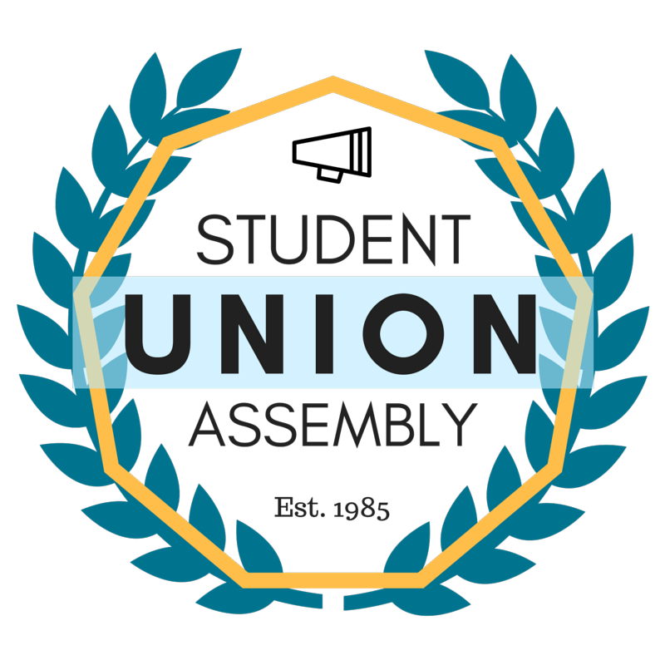
Student Union Assembly
Monthly Report
________________________________________________________________________________
SUA Mailstop: SOAR, 1156 High Street, Santa Cruz CA 95064 • P: 831.459.4838
suapres@ucsc.edu • sua.ucsc.edu
Under My duties as Vice President of Diversity and Inclusion of the Student Union Assembly and Article III Section a Subsection 6(l) of the SUA Constitution, I present my January 2017 monthly report and evaluation to the Assembly. I will outline all of my events, logistical planning, activities and constructive criticism with areas of improvement in hopes of providing a detailed account in the month’s report.

Ongoing Projects
Martin Luther King Convocation Planning Committee
1)Met with planning committee to plan this event several times this month. Since this event always seems to reach capacity, I advocated for students to have reserved sections at the event, including designated space for the SUA members.
2)We received notice that our original speaker was not going to be available on the event date due to health issues. It was discussed how to move forward in replacing the speaker.
SOFA
1)This month we met and reviewed funding for SOFA. We had a LARGE amount of applications. In our first meeting, we reviewed presentation from each organization, but were unable to make quorum. A subsequent meeting was scheduled for deliberation.
2)In our subsequent meeting, we deliberated on which organizations we would fund and how much would be funded. This was later approved in the meeting space.
Interns
This month I also finalized hire of my interns. I have scheduled orientations for them with our SUA Advisor. I have also oriented them to ongoing projects that the office is undertaking. They have been extremely helpful.

SACNAS
1) I have met several months with SACNAS leadership to plan and begin execution on planned events. We will be bringing students from Watsonville high school to campus. During this time, we will host a student panel of successful UCSC STEM students from underrepresented backgrounds to offer advice and answer questions. We will also be facilitating campus tours. A portion of this event will offer advise/ presentations from campus academic advisors.
2) An event was executed in this month, a mixer with SACNAS and SANAI, I was in attendance and helped acquaint the members of the orgs to each other.
Interfaith Prayer Space
This month I began working on the giving day application and execution for this project. The necessary forms were submitted in collaboration with the UIC. Advertisement for this will begin soon.
Police Student Relations
This month I have been in contact with the University Police, we began discussing hosting an event, dates were selected by the police and we have been in discussion as to the content of the event and what we want to offer students in this event.
Committee on Affirmative Action and Diversity
This month I met with CAAD and we discussed TOE hires.
STEM Diversity Programs
I have begun discussing ways the SUA can help underrepresented and undocumented students in STEM. This has mainly related to funding that is lacking for undocumented students.
NCAA Athletes
I have begun discussion on how SUA can enhance the exposure of NCAA athletes on campus and bring attention to their events
SUA Feedback
There is a large amount of conflict amongst officers. I am uncomfortable around one of the officers and this has affected my ability to be in the office at ALL. Other officers have expressed their discomfort working with this officer as well and I am troubled by this.
Chancellor’s Office of Diversity and Inclusion
I have met with representatives of this office and we have discussed reorganizing some structures in administrative and staff Diversity Organizations to improve our ability to respond to campus events and needs in a timely manner.

